Working screenshots

1. Employee tries to check-out without being checked-in (system throws error)

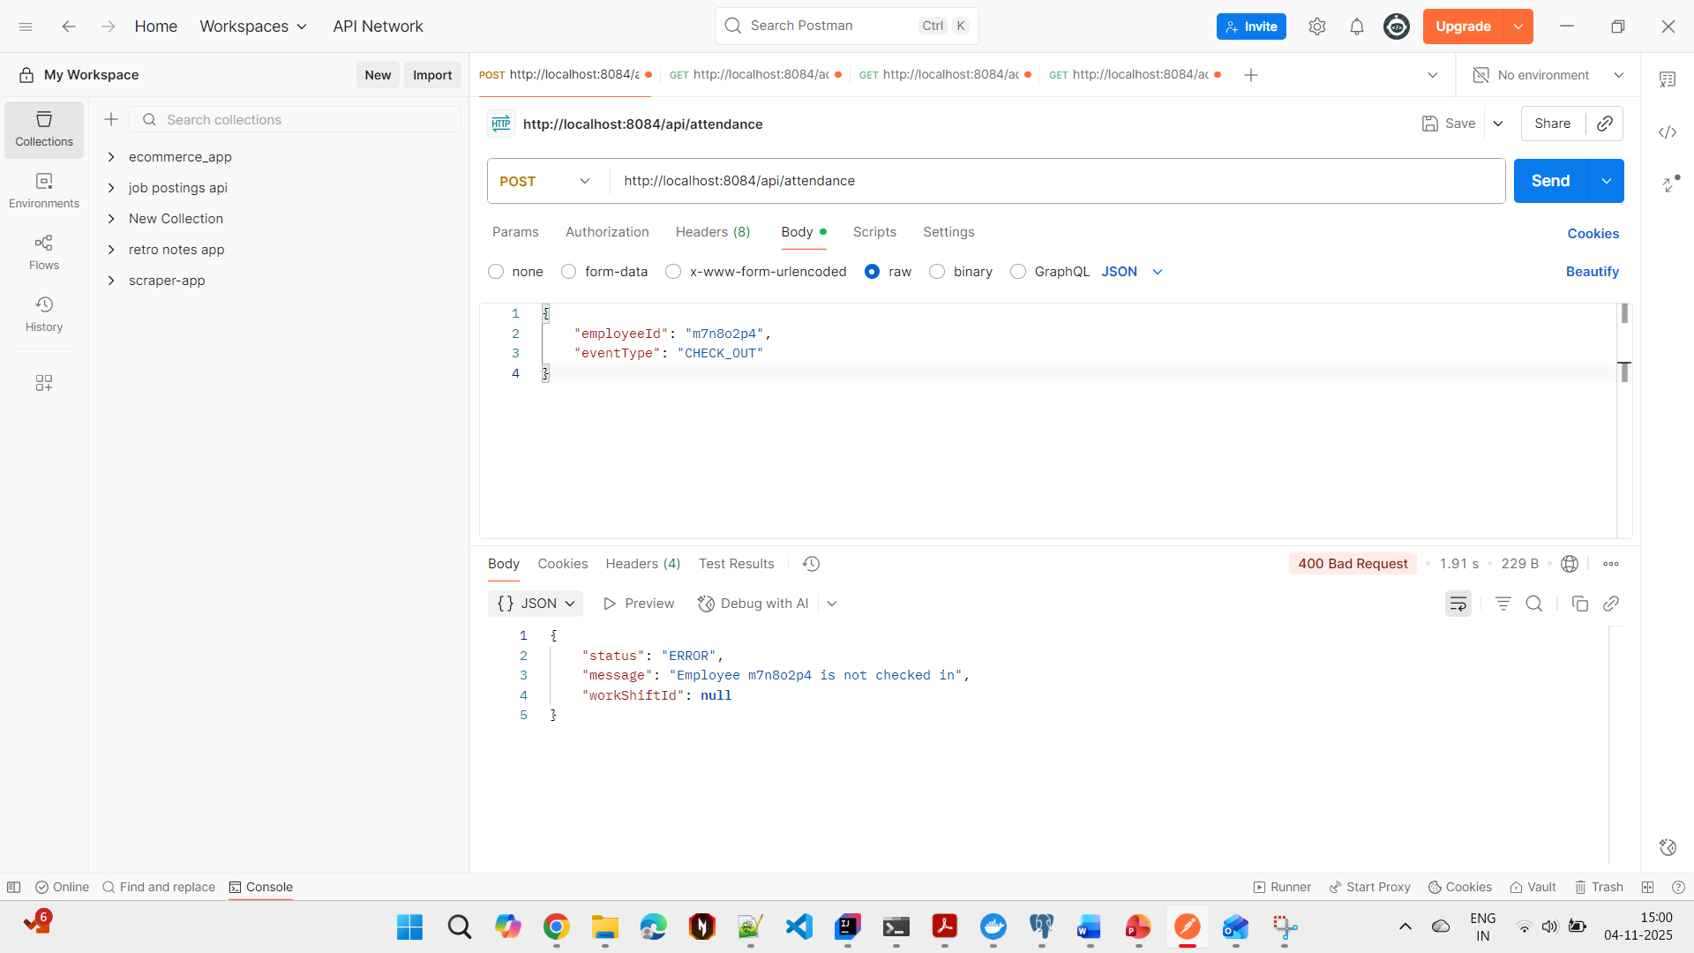

1. Employee (id = m7n8o2p4) checks-in

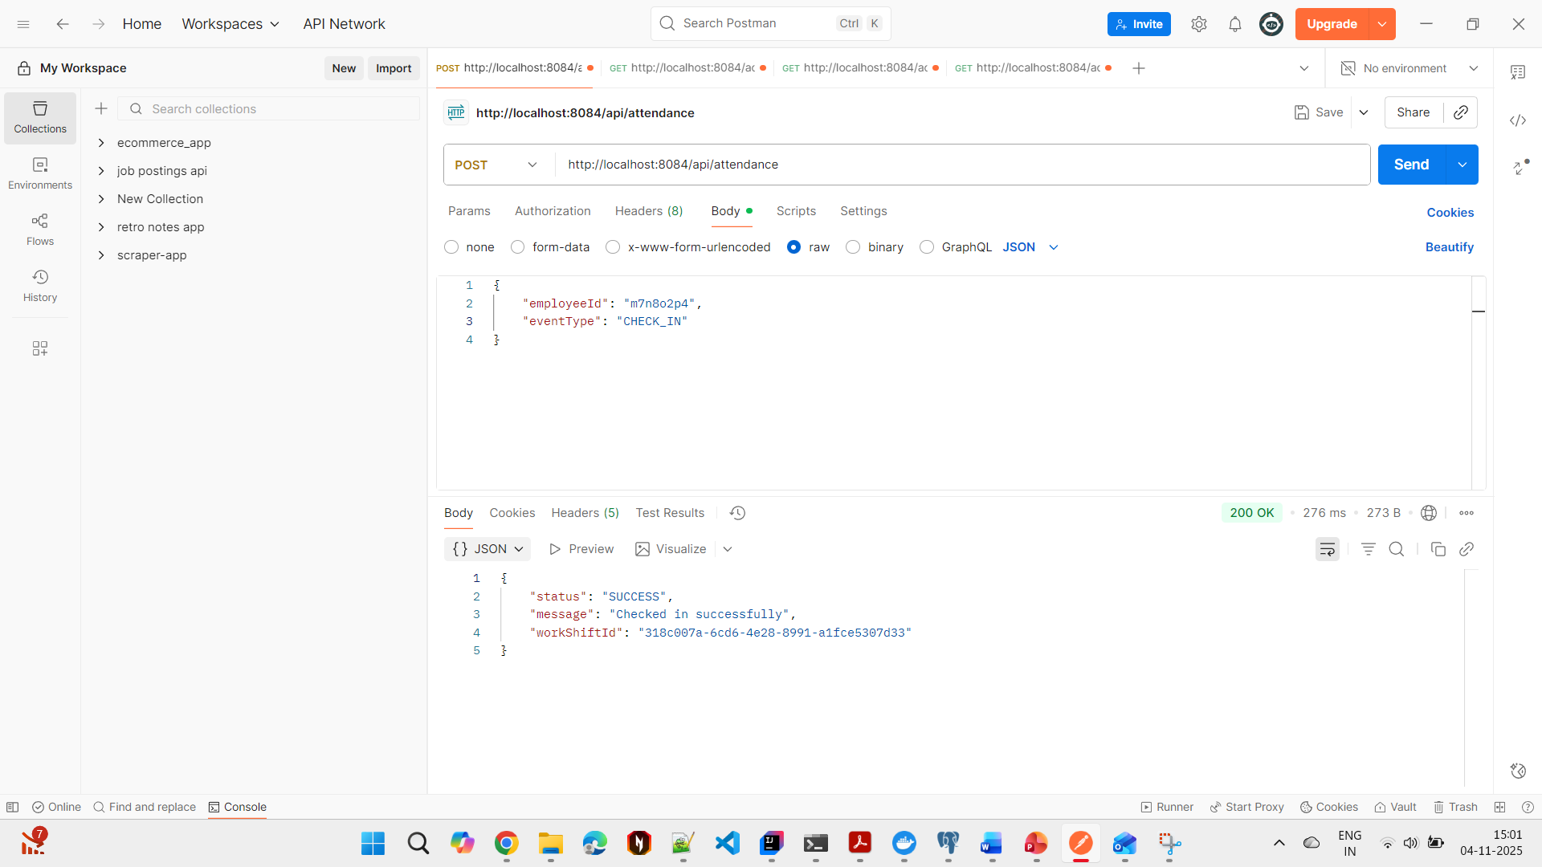

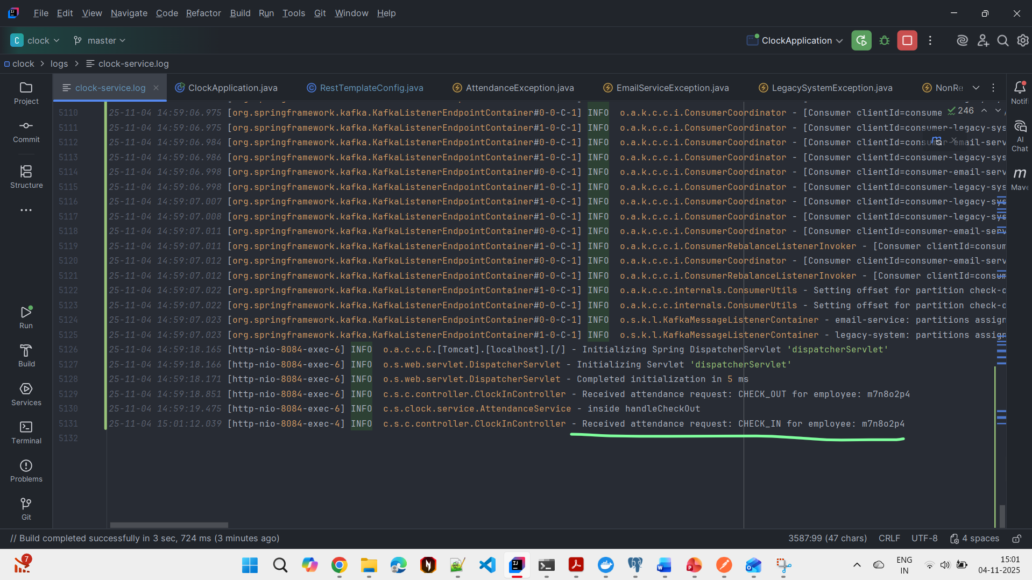

1. Database record created – highlighted row

status = ACTIVE (employee has not checked out yet)

email_sent = false and reported_to_legacy = false (employee has not checked out yet)

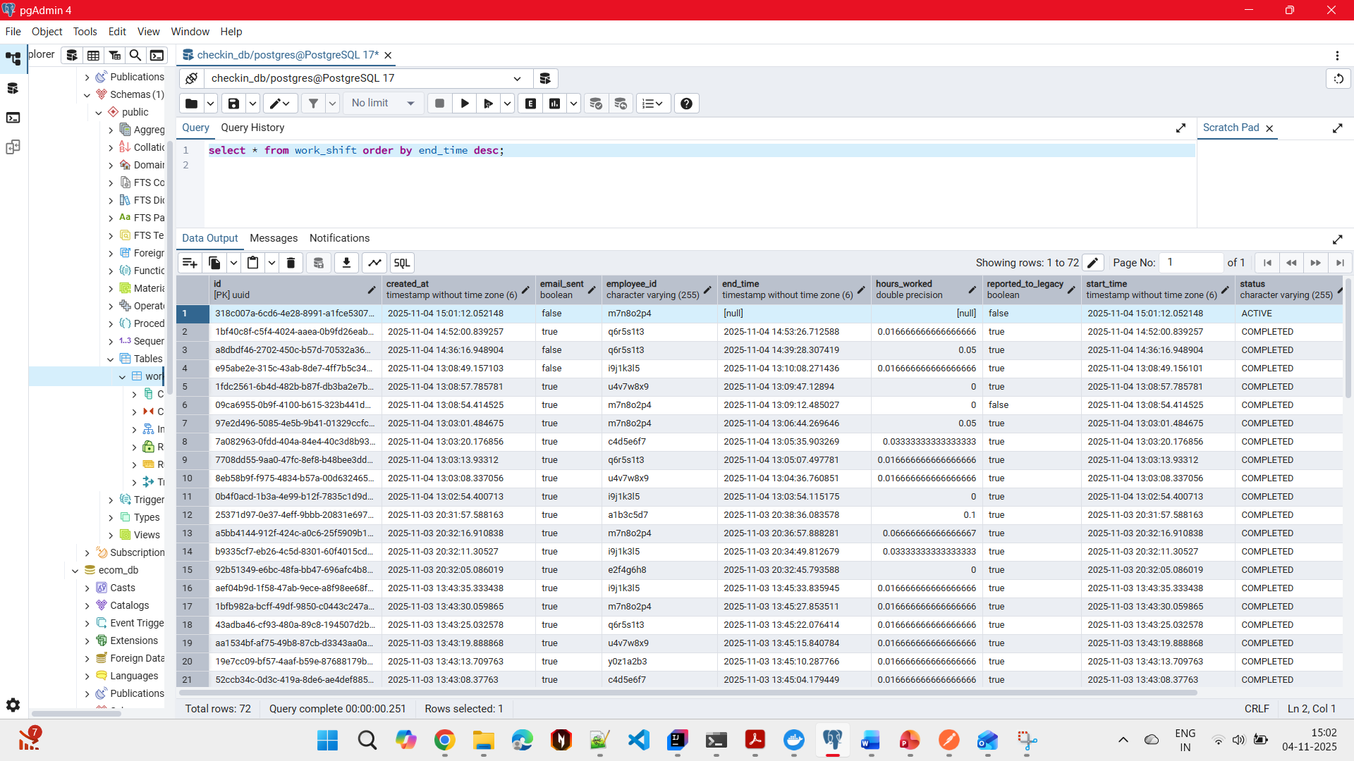

1. Employee (id = m7n8o2p4) checks-out

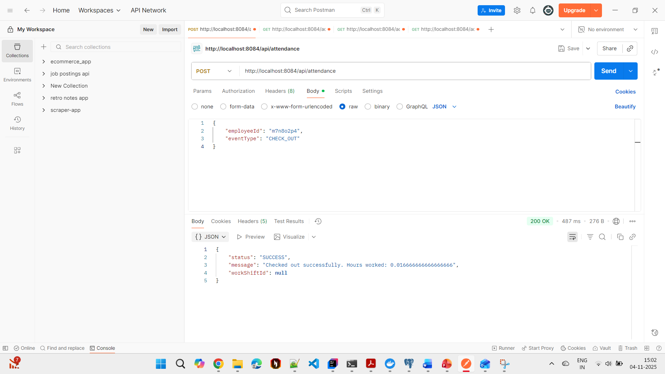

1. Logs from clock-service.log

Check-out event logged

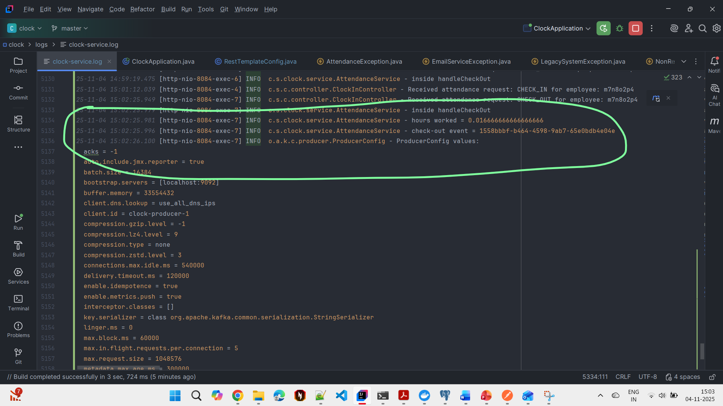

1. HTTP post request to external APIs - Mock legacy API and mock Email service

Mock legacy API fails with 503 error (simulated failure with 60% chance of failing)

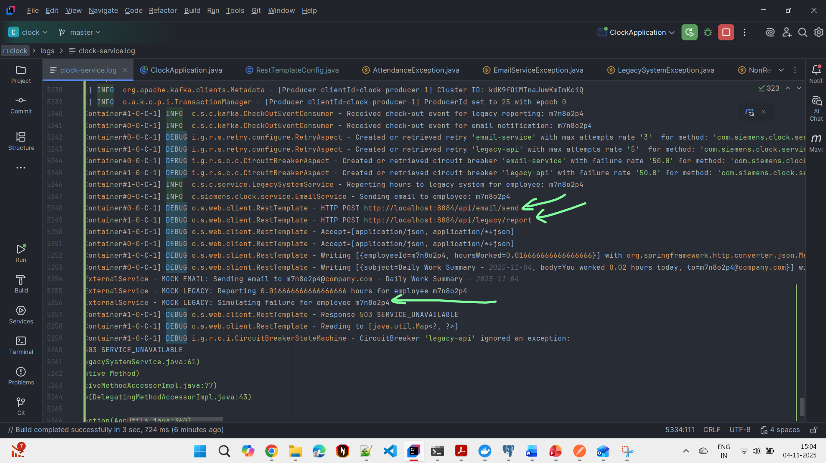

503 error – legacy reporting service not available

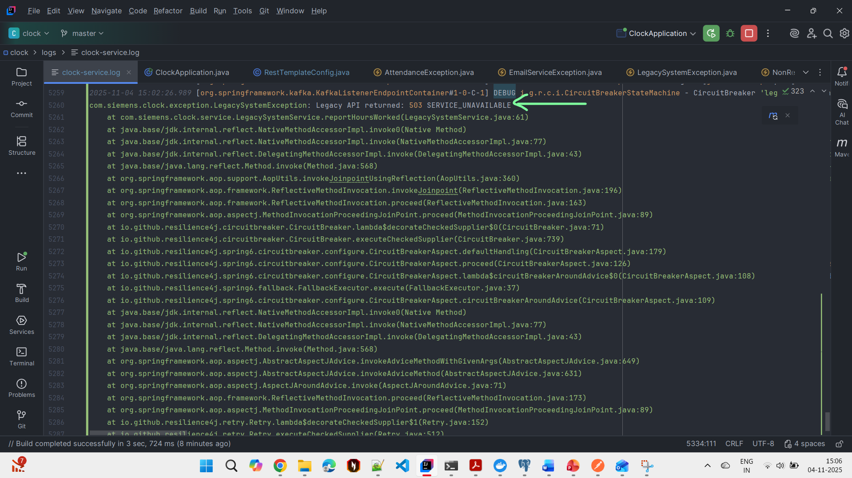

Retry triggered for Legacy API – is successful this time (2nd try)

Email service is successful on first try

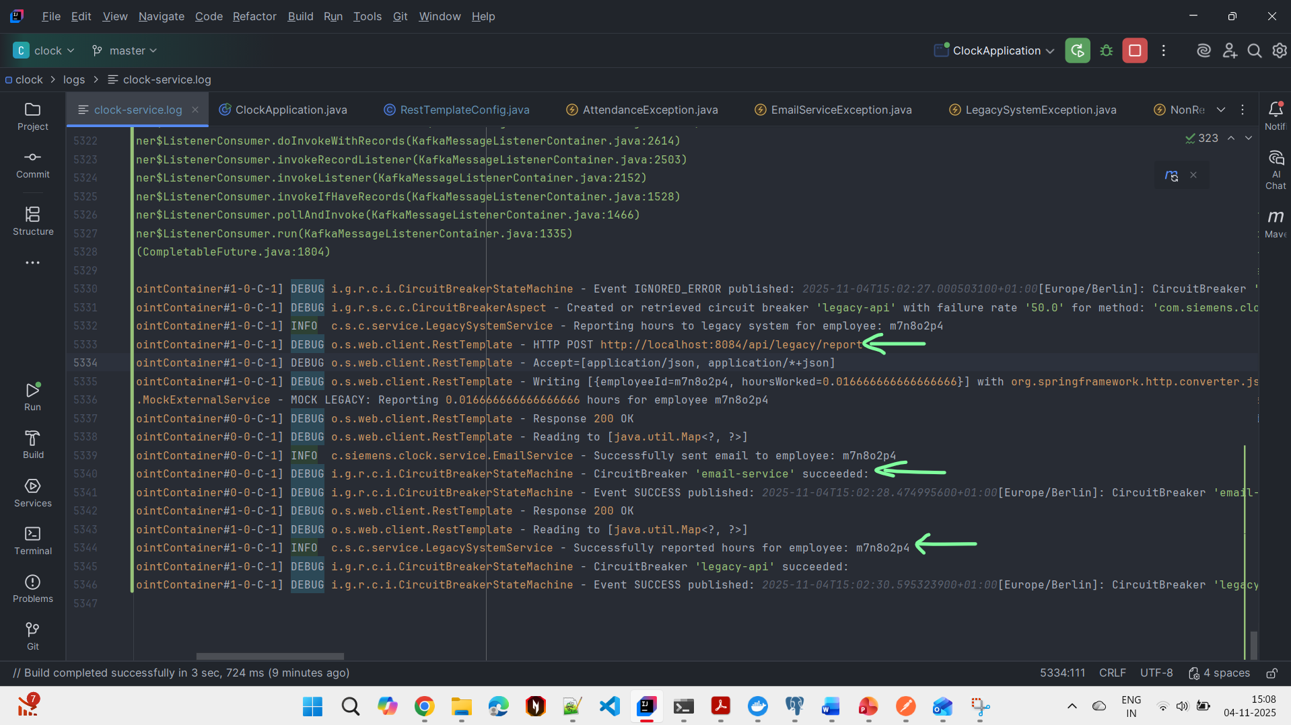

1. Database record updated

Status = COMPLETED

Email_sent = true

Reported_to_legacy = true

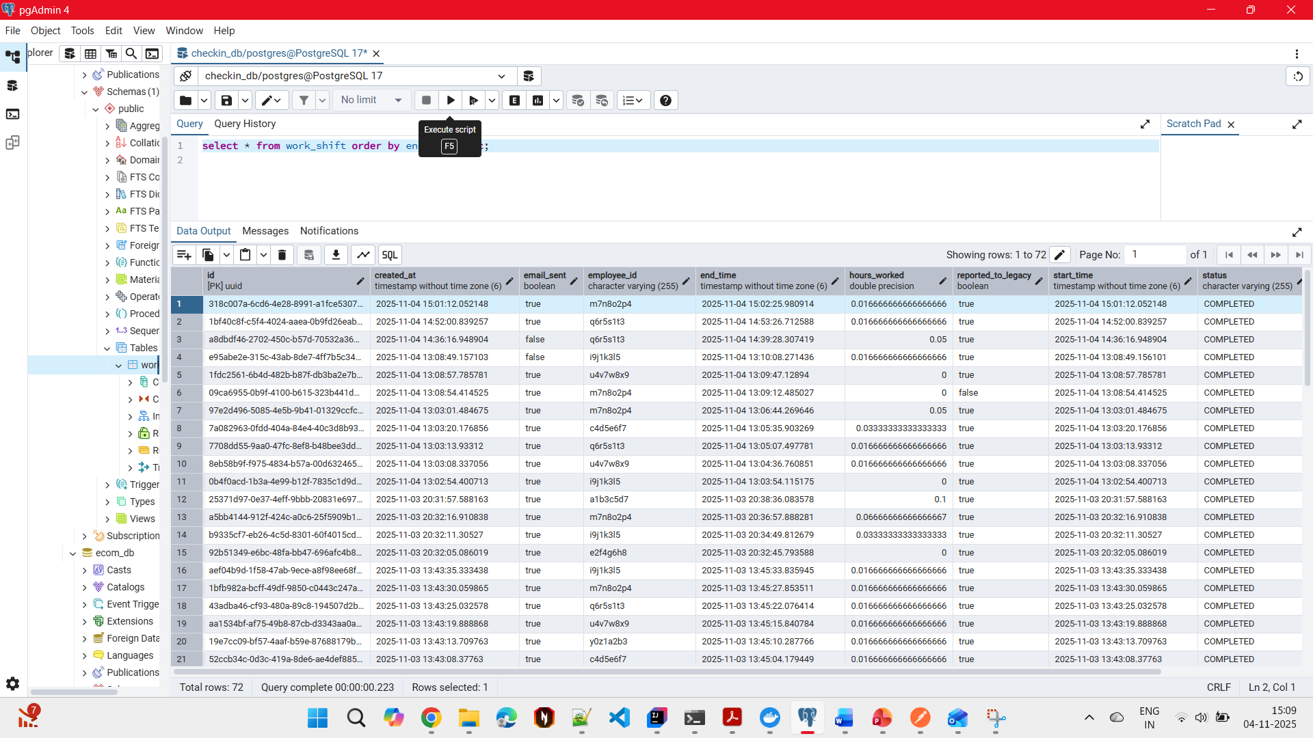

1. Our prometheus endpoint at <http://localhost:8084/actuator/prometheus> confirms that legacy API was successful with 1 retry and email service was successful without any retry

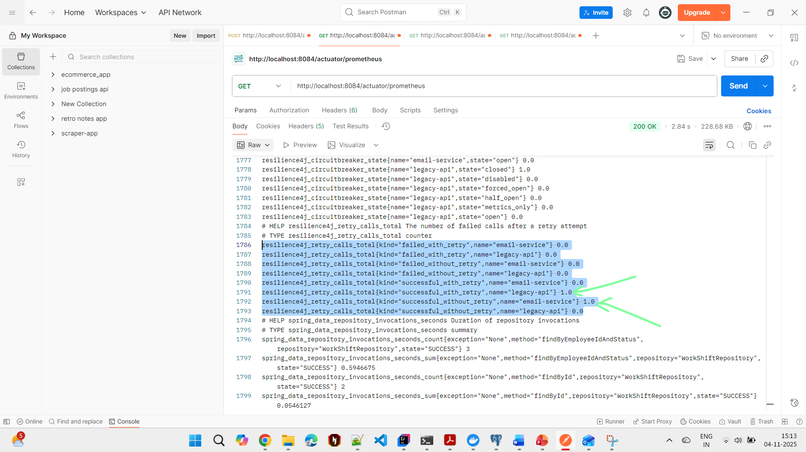

As there are no failed messages our messages do not end up in the check-out-dlq (DLQ for Legacy API) and email-dql (DLQ for Email service)

1. Below screenshots are from failed messages that ended up in the check-out-dlq and email-dlq

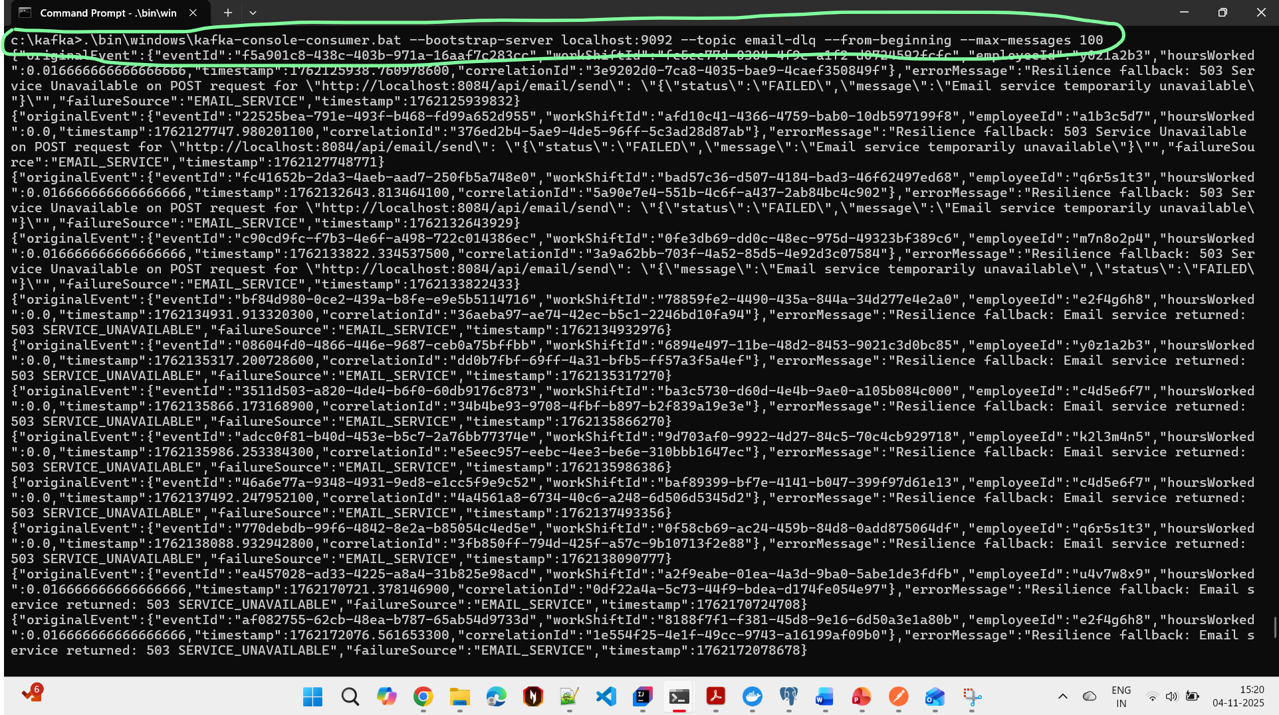

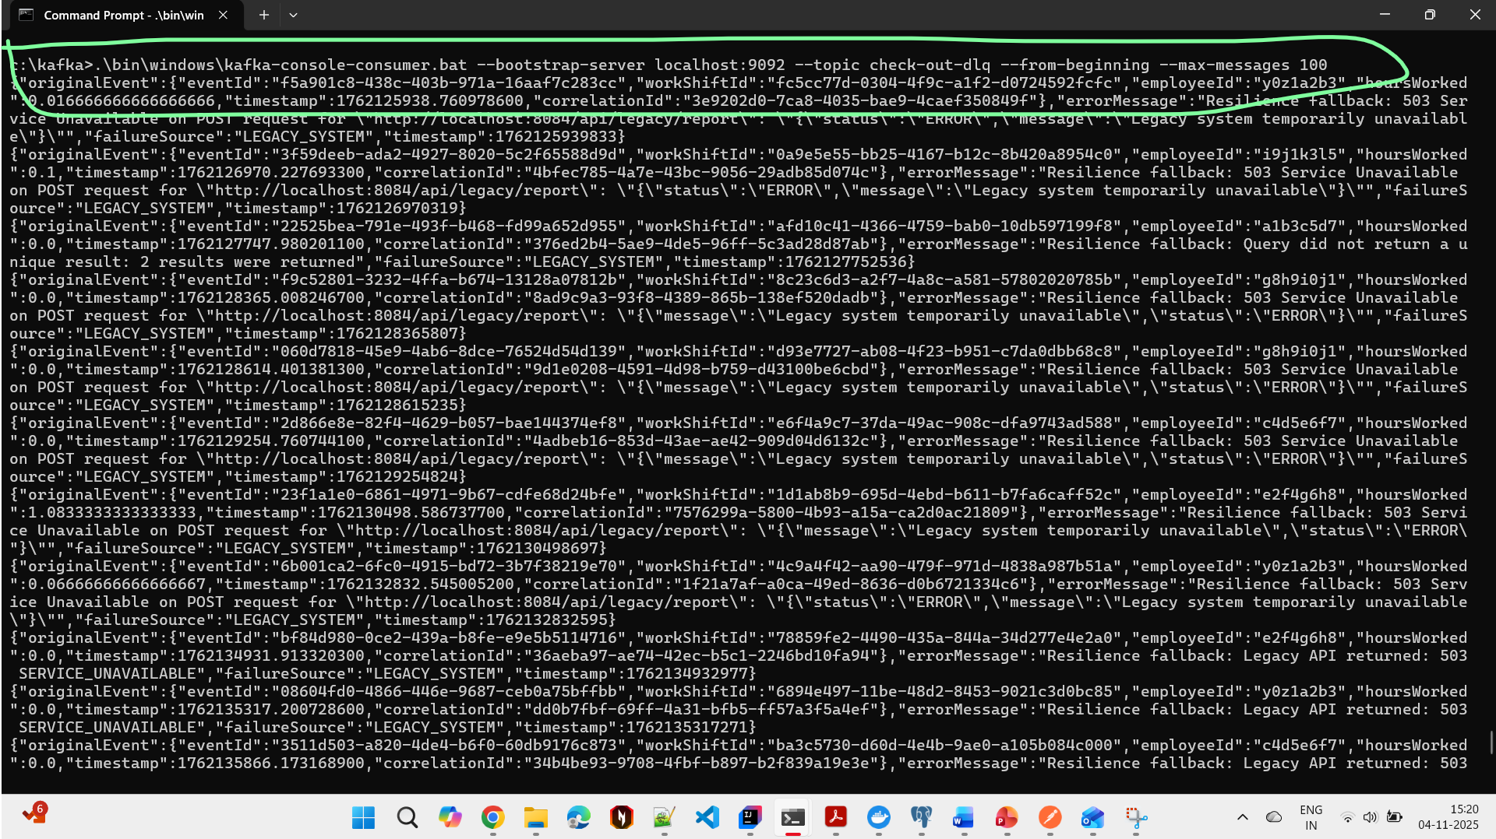

1. Alerts generated for messages in DLQs (alert.log)
2. *2025-11-04 13:09:13.415* [ALERT] ERROR - --- INCIDENT ALERT RAISED (CRITICAL) ---  
   *2025-11-04 13:09:13.416* [ALERT] ERROR - Title: Unrecoverable Failure in LEGACY_SYSTEM  
   *2025-11-04 13:09:13.416* [ALERT] ERROR - Details: Event ID 09ca6955-0b9f-4100-b615-323b441d0801 for Employee m7n8o2p4 failed all retries. Error: Resilience fallback: Legacy API returned: 503 SERVICE_UNAVAILABLE  
   *2025-11-04 13:09:13.416* [ALERT] ERROR - Timestamp: *2025-11-04 13:09:13  
   2025-11-04 13:09:13.416* [ALERT] ERROR - Metadata: {dlqTimestamp=1762258153392, employeeId=m7n8o2p4, source=LEGACY_SYSTEM, workShiftId=09ca6955-0b9f-4100-b615-323b441d0801}  
   *2025-11-04 13:09:13.417* [ALERT] ERROR - ---------------------------------  
   *2025-11-04 13:10:09.913* [ALERT] ERROR - --- INCIDENT ALERT RAISED (CRITICAL) ---  
   *2025-11-04 13:10:09.914* [ALERT] ERROR - Title: Unrecoverable Failure in EMAIL_SERVICE  
   *2025-11-04 13:10:09.914* [ALERT] ERROR - Details: Event ID e95abe2e-315c-43ab-8de7-4ff7b5c34e1e for Employee i9j1k3l5 failed all retries. Error: Resilience fallback: Email service returned: 503 SERVICE_UNAVAILABLE  
   *2025-11-04 13:10:09.914* [ALERT] ERROR - Timestamp: *2025-11-04 13:10:09  
   2025-11-04 13:10:09.914* [ALERT] ERROR - Metadata: {dlqTimestamp=1762258209908, employeeId=i9j1k3l5, source=EMAIL_SERVICE, workShiftId=e95abe2e-315c-43ab-8de7-4ff7b5c34e1e}  
   *2025-11-04 13:10:09.914* [ALERT] ERROR - ---------------------------------  
   *2025-11-04 14:39:31.098* [ALERT] ERROR - --- INCIDENT ALERT RAISED (CRITICAL) ---  
   *2025-11-04 14:39:31.104* [ALERT] ERROR - Title: Unrecoverable Failure in EMAIL_SERVICE  
   *2025-11-04 14:39:31.104* [ALERT] ERROR - Details: Event ID a8dbdf46-2702-450c-b57d-70532a36b41b for Employee q6r5s1t3 failed all retries. Error: Resilience fallback: Email service returned: 503 SERVICE_UNAVAILABLE  
   *2025-11-04 14:39:31.105* [ALERT] ERROR - Timestamp: *2025-11-04 14:39:31  
   2025-11-04 14:39:31.105* [ALERT] ERROR - Metadata: {dlqTimestamp=1762263571085, workShiftId=a8dbdf46-2702-450c-b57d-70532a36b41b, source=EMAIL_SERVICE, employeeId=q6r5s1t3}  
   *2025-11-04 14:39:31.105* [ALERT] ERROR - ---------------------------------